A CRM APPLICATION FOR THE SCHOOLS AND COLLEGES

TEAM LEADER : R.Arthi

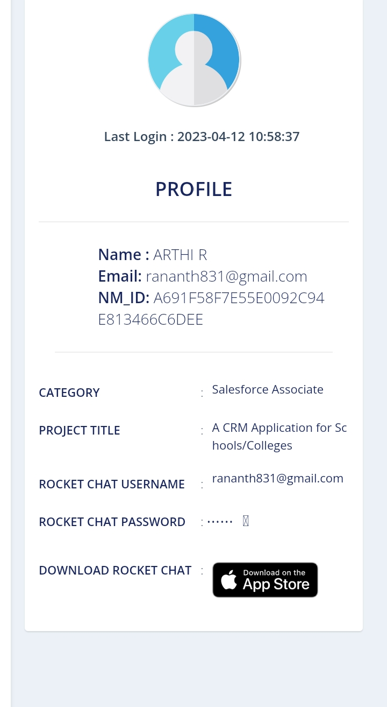

Team Member1: R.Abinayasri

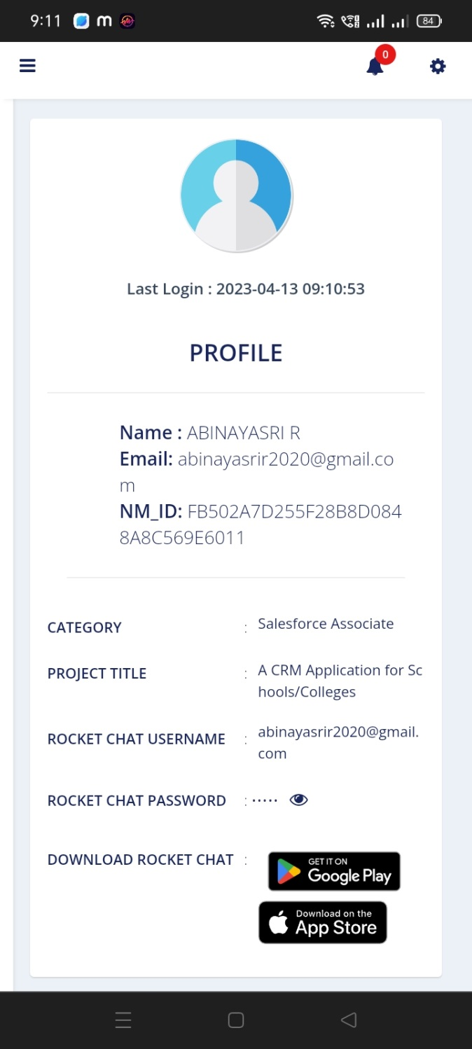

Team Member 2: A.Ajitha

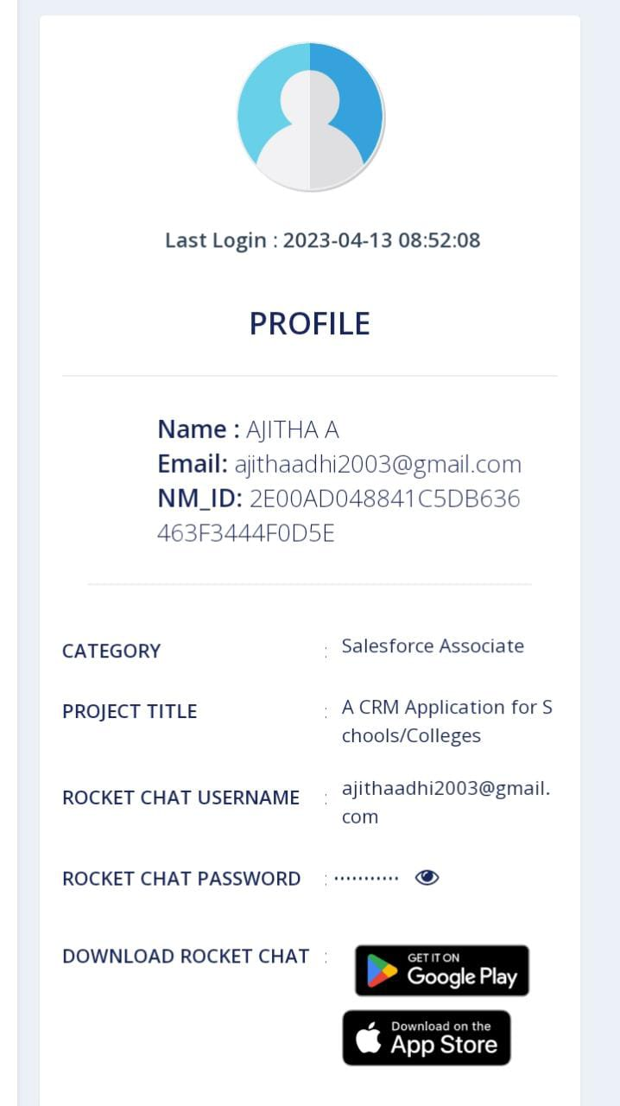

Team Member 3: S.Anitha

